**TALKING ABOUT PROJECT-RELATED PROBLEMS**

*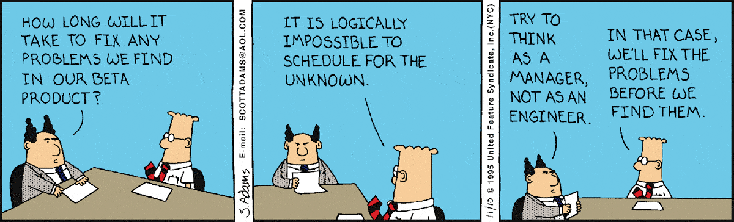****1.*** *When showing the product to the customer during a meeting, what can possibly go wrong?*

*Think of a time when your customer pointed out a project-related problem during a meeting (i.e. the application isn’t running in Chrome / time format isn’t displayed correctly etc.) What did you/your teammates say when the customer pointed out a problem? / What would you say if the customer did that? How would you feel?*

***2.*** *Listen to the recording. What is the problem and how will Reva deal with it?*

***3.*** *Listen again and fill in the gaps with words/phrases you hear*.

(1) There _____________ to be a small problem with...

(2) What's the problem ____________?

(3) It's good that you _____________________ to my attention.

(4) This is ______________________ to do. I'll...

(5) I'll _________________________ it doesn't happen again.

***4.*** *Which of the sentences above can you use to do the following? Put them into the table.*

|  |  |
| --- | --- |
| **Acknowledge the problem / ask about the problem /comment on the situation** |  |
| **Explain the cause of the problem / think aloud** |  |
| **Promise action / give time estimates** |  |

***5a****. Read the scripts below and fill in the gaps with the phrases from the box:*

|  |
| --- |
| * it might be due to * we'll look into it * get back to you *  * talk it over with the team * be related * |

[video 1](https://youtu.be/NPD6rrVFaI0?t=21m17s) [21:17 to 21:30]  
… the part that was concatenated to the default value. I'm absolutely puzzled by what would be causing the behavior, actually.  
Trevor: OK, **(1)** _______________________ a bit more and see if we can get an answer and update  
the stack overflow for you.

[video 2](https://youtu.be/97HLa739rXU?t=44m6s) [44:06 to 44:15]

Look, it's not there right now. **(2)** **Let me**_______________________. There may be reason that we didn't do that. And **(3)** _______________________.

[video 3](https://youtu.be/wiJ8bwTi17U?t=46m9s) [46:09 to 46:26]

We relay that information on to the engineers, and the engineering team's looking into this.  
And the problem may not even lie with Gmail. **(4)** **It may** _________________**to** the Google account framework, and causing some sort of problem.

[video 4](https://youtu.be/TshYsRI4GUU?t=1968) [32:47 to 33:03]

Male #2: Some very large JSON responses. And this can cause our app to run out of memory.  
**(5)** _____________ memory pressure from other things going on the app. But how do you suggest  
handling such large responses?  
Trevor: Ah. Excellent question. So, if you control the API, you could go and page your…

***b****. Now follow the links and check your answers. When you’re done, add these phrases to the table in (4).*

***6.*** *Here are some more phrases that you can use to talk about problems. Can you figure out what the missing letters are?*

1. We haven’t e__ __ __ r__ __ n__ __d this problem /situation / behaviour before.
2. I’m going to have a look into this s__ r__ __ gh__ a__ __ y.
3. Hopefully we’ll finish this s__ __ r__ __ y / __ __ the next several days / __ __ Friday __ __ the latest.
4. Thank you for p__ __ __ t__ __g that o__ __.
5. The reason __ __ __ that might be that…

*Now add these phrases to the table in (4).*

***7.*** *Play noughts and crosses with a partner.*

|  |  |  |
| --- | --- | --- |
| What’s the problem _____? | We’ll try to sort it out _______ [=soon]. | It might be _____ using the wrong credentials. |
| We’ll finish this ___ the next several days | I’ll look into it _________ away. | This is what ________ do. |
| Thank you for ______ that out. | It’s good that you’ve _______ it to my attention. | We haven’t _______ that before. |

|  |  |  |
| --- | --- | --- |
| Hopefully we’ll finish this __ next Friday __ the latest | The problem may be related ___ the wrong settings. | I’m going _______ a look into this. |
| We’ll make ________ everything works the way it should. | Thanks for pointing _____ _____. | I’ll _______ into it immediately. |
| I’ll get ________ to you straight _____ | Let me talk it ____ with the team. | There ___ to be a minor problem with the font. |

|  |  |  |
| --- | --- | --- |
| Thank you for ________ that _____. | There _______ to be a small problem with… | I’ll have a ______ into this _____ away. |
| I’ll ____ back ____ you tomorrow. | This could be ____ to several factors. | We haven’t _______ such behavior before. |
| Let me _____ it over with the team | Thanks for _______ this ___ my attention. | The reason ___ that ____ be that we didn’t optimize it. |

***8.*** *Work with a partner. Each turn, toss a coin (heads = one step forward, tails= two steps forward) and say a sentence containing the word /phrase in the field*.

experienced

due

related

exactly

appears

look

pointing

to my attention

talk over

**Start**

**go back**

shortly

get back

straight away

reason

latest

make sure

**Finish**

***9****. Work in groups of three. Read the scenario below and role-play a dialogue.*

Student A. You’re a customer. Pick a problem from the box below. Tell your partner what it is.

Student B. You’re doing a demo for the customer. He/she will point out a problem.

* Acknowledge it / say the problem is new
* Explain what the cause of the problem could be
* Promise some action.

Student C. Listen to Students A and B and note down the language from the lesson that Students A and B use.

*When you finish, swap roles.*

|  |
| --- |
| * One of the buttons is too small * It takes too long to remove a line from a table * After you press ‘refresh’ the width of the columns is different * Only half of the options are implemented * The app keeps crashing in Chrome * One of the buttons is square but it’s supposed to be round * The interface isn’t user-friendly (difficult to navigate on the website) * The fonts are too small, the colors are too bright * The ‘cancel’ button isn’t working |